Sea voyages in the 18th and 19th century.

An investigation of how sea voyages in the age of sail were routed, the distance they traveled and how efficient the routes they took were.

**Gustav Ølgaard**

Student reg. no.: 201905099

Spatial Analytics | Aarhus University

Course Instructor: Adéla Sobotkova

Github repository: <https://github.com/G-Oelgaard/Spatial_final_assignment>

Date: 07/06/2022

# Abstract

In the age of sail what routes did sea voyages take and how long and efficient were they? This paper examines this using the database CLIWOC containing 287.000 logbook entries and a currents raster obtained from GlobCurrent. The efficiency of voyages was measured by determining whether voyages sailed with or against ocean surface currents. However, due to the absence of a north-south currents raster and considerations on the influence of wind, the results were flawed. However, voyages clear preference was shown towards efficient routes vs. direct routes. Notable Dutch voyages from Indonesia were highly efficient. Dutch ships also traveled longer in more numbers than any other nation, although all nations ships mainly kept to their respective spheres of influence.

**Keywords:** *Spatial analysis, raster extraction, spatial distance measurement*

Contents

Abstract 2

1. Introduction 4

1.1 Relevant bibliography 4

2. Methods 4

2.1 Software framework and requirements 4

2.2 Data 4

3. Results 6

3.1 Shipping route patterns 6

3.2 Voyage lengths 7

3.3 Route efficiency 7

4. Critical evaluation 9

4.1 Ocean currents as a marker of efficiency 9

5. Conclusion 10

References 11

Appendices 11

# 1. Introduction

What routes did sea voyages take in the 18th and 19th century? Since the advent of steam and oil-powered ships, routes can afford to take very direct routes. However, such was not always the case. In the age of sail ships the laws of nature played a far greater role than today. It would therefore by rewarding to examine whether there are any patterns in shipping routes. Furthermore, it would be interesting to examine if these voyages were as influenced by ocean currents as previously presumed, of if they chose to “bite the bullet” to reach valuable and important trading regions.

In other words, this paper seeks to examine where, how long and how efficient the sea voyages in the 18th and 19th century were.

## Relevant bibliography

The two main larger and related works are that of the *CLIWOC final report*, and the paper *Big data of the past: Analysis of historical freight shipping corridor data in the period 1662–1855*. Where the first is used to understand how the logbook data was collected and how it was first used, the second paper is a practical example on the use of the data in a way very reminiscent of this assignment. However, while the second paper examines the routes and their length, it does not try to plot or calculate which routes were efficient and which weren’t. This assignment will try to investigate this aspect.

# 2. Methods

## 2.1 Software framework and requirements

This project was created and tested on a 2017 MacBook Pro with 8Gb ram and Dual-Core intel core i5 using macOS Big Sur (v. 11.5.1), R-studio version 1.4.1717 and R version 4.1.1. The package requirements can be seen in the table below.

|  |  |
| --- | --- |
| **Packages** | **Version** |
| tidyverse | 1.3.1 |
| sf | 1.0-4 |
| raster | 3.5-2 |
| geojsonsf | 2.0.1 |
| rgdal | 1.5-27 |
| ncdf4 | 1.19 |
| RColorBrewer | 1.1-2 |
| maptools | 1.1-2 |
| ggplot2 | 3.3.5 |
| scales | 1.2.0 |

## 2.2 Data

Climatological Database for the World's Oceans, or CLIWOC for short, contains ca. 287.000 different logbook entries across 8 nations from 1662-1855. The dataset is especially useful due to their work altering the prime meridians used in the original navigation. This is because it was commonplace to switch it multiple times during a single trip, meaning plotting the original coordinates would be practically unusable.[1] The original EU-funded project was created in the early 2000's as a cooperation across a range of different unversities. Although it was intended to be used to, as the name might suggest, map and research climatological behavior and changes, it has since been used for a wide range of different purposes. As might have bee expected from a project created in the early 2000's, it is however not very accesiable as it requires the use of programs such as MS ACCESS. Thankfully the database has been updated by others and can now in more modern formats. No changes to the contents of the data before importing it into R-studio were made.

**Figure 1:** The route of HMS Surprise when plotting using the original coordinates (top) and corrected coordinates (bottom). Source: CLIWOC Final Report (2003)

Due to the size of the data, it was decided to only plot british, dutch, french and spanish voyages. The nations had 2157, 1934, 257 and 813 voyages respectively after unusable data was sorted out. Furthermore, only a few relevant variables such as ID, voyage start dates (combined to create a voyage identifier) and lat-long placement were used. It should be noted that while this is a large dataset, it in no way encompasses all voyages in the relevant era.

But how much can conclude with the use of CLIWOC. As mentioned previously, whilst large, it only contains a fraction of all voyages in the era. Most striking is the almost complete lack of trade outside of the nation’s respective spheres of influence – i.e., their colonies, puppets, or close trading partners. The explanation for this might be twofold. Firstly, the advent of free foreign trade was only just beginning. Ships might in other words not have been allowed to trade in many areas, or were unwilling to due to high tariffs. Because of these restrictions, smuggling became rampant in the era. It might therefore not be inconceivable that ships purposefully neglected to log their voyages, as to not create any evidence of their wrongdoings. Secondly, all CLIWOC’s logbooks were obtained from archives generally from the 4 primary nations. Logbooks of ships that focused on foreign trade might therefore very well be in other nations archives or simply been lost.

Nonetheless CLIWOC is most in-depth data available when it comes to sea voyages. While it would be prudent not to make any too definitive statements about the voyages in the age of sail, it certainly can be used as a general indicator on the conditions and realities of the time.

GlobCurrent provided that files needed to create the currents raster. While the original .nc files contained directional information, it was lost when it was converted to a raster file. As the north-south current raster were also deemed unusable[2], route-efficiency is based exclusively on east-west currents! The data used was the total surface currents on the first of january 1993. As ocean currents have been observed to be accelerating in recent years, it was important to use the oldest data available to best model currents that might match those 150+ years earlier. Access to the data requires a free and simple registration.

# 3. Results

The following sections are a quick overview of all the results obtained through the assignment.

## 3.1 Shipping route patterns

The first and most immediate results obtained were plots showing the routes the ships took. While this is not a result of any significant spatial analysis, but mainly just plain data visualization, it is still useful to help us understand how to data looks without altering it any further.

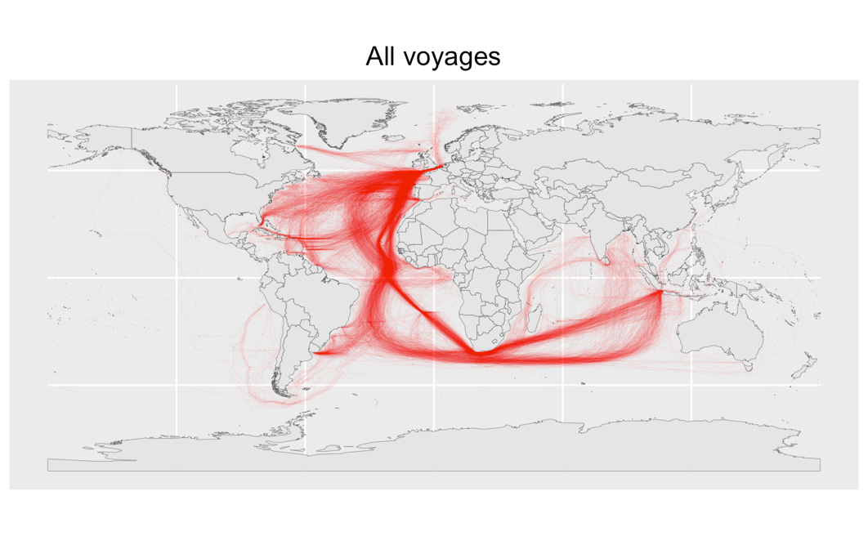

**Figure 2.** Map of all voyages[3]

Already without altering the data, some clear patterns are visible. Most notable are the two routes which almost all ships take around the cape of Africa. When split into east and west going voyages, it becomes even more clear that ships favor certain routes.[4] These routes are in most cases in no way the most direct, and thereby further cements the idea that direct routes are inefficient. As such we need to investigate other factors that play a part in determining voyage routes. First let’s look at voyage lengths.

## 3.2 Voyage lengths

This assignment originally intended to compare the most direct Euclidean distance with length of the routes actually taken. Sadly however, the choice was made to focus on other problems. Nevertheless, by using the function “st_distance” on every single voyage’s linestring, a precise length of each voyage could be obtained.[5]

**Figure 3.** Histogram of voyage length by nation.

While the average distance travelled was 9074.1 km, the spread was not identical amongst the different nations. Most notably more Dutch shipped travelled distances over 20.000 Km than any of the other nations, indicating their tendency to send ships to Indonesia. While Britain also sends ship all the way around Africa to India, their numbers are far fewer.

## 3.3 Route efficiency

But what about the efficiency of the voyages? Did they take the most optimal routes? First, we must define efficiency. In the follow section, efficiency is the combined sum of the values extracted from the currents raster[6] that each the voyage intersects. As will be discussed in section 4.2 this approach is lacking in some respects and might not be the best indicator possible, but it is the best this assignment could produce.

By measuring the efficiency by currents and then reversing the results for west-going voyages[7], we get a value with which we can compare all routes no matter their general direction. While the efficiency values range from -86.44 to 177.91, the mean value efficiency value of all voyages is 18.87 meaning most voyages choose routes that, while not very efficient, at least aren’t directly inefficient.[8] In other words: routes generally tend to avoid areas that would sail against the current.

**Figure 4.** Map of routes based on efficiency after reversing the route efficiency values of westward going voyage. Note the high efficiency of voyages going from Indonesia to Europe.

When plotting routes based on efficiency (figure 4) another aspect of the data becomes clear. Routes heading towards Europe from Asia are by far the most efficient, traveling long distances in areas with helpful westward currents. On the other side, many east-bound routes to Asia tend to stay closer to the cape of Africa instead of further south where the currents are more favorable. However, this is probably most likely due to prioritizing trade and supply concerns. The harbor city of Cape Town (sometimes referred to as Kaapstad) also seems to be the first stop after leaving Europe for most voyages[9]. It might therefore be concluded that more efficient routing would certainly be possible, although it probably would have resulted in the already dangerous voyages becoming even more perilous, both in terms of the health of crew and ship.

While most nations have a very similar spread of efficiency, the Dutch manage to maintain a higher efficiency score than their counterparts.[10] This became even more apparent when calculating their individual mean scores. The Dutch mean score of 26.674 in significantly higher than any of the others nation scores: 16.9 (Spain), 13.759 (France) and 13.143 (Britain). While one might be tempted to conclude that the Dutch were the superior navigators, it might also be due to fact that their end destination often was Indonesia. As can be observed in figure 3, the voyages to, and especially from, Indonesia could almost always make use of favorable currents, whilst many of the other nations often had to take more inefficient routes to reach their desired destination.

**Figure 5.** voyage efficiency by nation.

As hinted to in the paragraph above, in most cases the inefficient routes[11] often have a logical explanation. In most cases it is likely due to efficient routing be far longer both in time and distance. It was so to say probably favorable “bite the bullet” than to find a route that would sail with the currents. This is most definitely the case with many routes going to northern America.

# 4. Critical evaluation

## 4.1 Ocean currents as a marker of efficiency

The use of a raster converted from a .nc file, while effective at modeling east-west currents, has a critical flaw. The lack of north-south currents. While it was attempted to retrieve and use a raster that would model these currents, it was not achieved in time. As such the voyage efficiency results should be taken with a large grain of salt. Some voyages that might seem efficient or inefficient, could very well be the opposite. The most obvious case of this are the voyages heading south from Europe towards Asia. If we map the ocean currents as they should appear, it becomes clear that they do in fact take a very efficient route south towards equator.[12] In other words: the not so efficient routes towards Asia might not be as inefficient as they appear.

**Figure 6.** Eastbound voyages overlaid with ocean currents. Note the voyages following the current south towards equator.

Furthermore, while currents might be a good indication of route efficiency, it is not the only relevant variable. When travelling at sea in the age of sail, the wind also plays an important role, if not even more important than currents. Whilst it is true that currents are generated in part from wind, it would have been a more complete efficiency calculation if was included as a standalone variable. While wind is a lot more undependable than currents, some general wind patterns do occur, and they could therefore in theory be modelled. However, the data could not be procured in time. Even if with the data it would have been unknown how to realistically model and weigh its importance compared to ocean currents.

The combination if raster and spatial objects also provided another, albeit in perspective relatively minor, problem. The extraction of raster values using “raster::extract()” took over two hours to run. This meant that any changes made to the spatial object would lead to a lot of downtime. Combined with another code block measuring the distance between voyage coordinates that also took ca. 1.5 hours, any changes made before these code blocks, had to be made with great consideration. As such some ideas were scrapped before they could even be tested. It should be noted that these long calculations were probably primarily caused by the sheer size of the data, rather than the functions themselves.

# 5. Conclusion

In the age of sail ships had to navigate by the rules of nature. Even though the shortest and most direct routes to wealthy or important areas may seem like the most logical, ships often chose completely different and far longer routes. While still primarily sailing between the nations respective spheres of influence, Although the results of this assignment have been undercut by the lack of north-south currents, a clear tendency to choose efficient routes that follow currents can be observed. Especially the route between Indonesia and Europe, sailed primarily by the Dutch, can be noted for its high efficiency.

Although very rewarding, this assignment also demonstrated the large amount of time needed for calculations when combining functions such as “st_distance()” or “raster::extract() and big data.

# References

"Three Ways to Calculate Distances in R." R-bloggers, 2020, accessed 06/06/2022, <https://www.r-bloggers.com/2020/02/three-ways-to-calculate-distances-in-r/>.

"Climatological Database for the World's Oceans." Historical Climatology, 2018, accessed 07/06/2022, <https://www.historicalclimatology.com/cliwoc.html>.

García Herrera, Ricardo, Dennis Wheeler, Gunther Können, Frits Koek, Phil Jones, and Maria Rosario Prieto. "Cliwoc Final Report." (2003). <https://webs.ucm.es/info/cliwoc/Cliwoc_final_report.pdf>.

"Data Catalogue." GlobCurrent, 2013, accessed 05/06/2022, <http://globcurrent.ifremer.fr/products-data/data-catalogue>.

"Drawing Beautiful Maps Programmatically with R, Sf and Ggplot2 — Part 1 and Part 2." r-spatial, 2018, accessed 05/06/2022, <https://r-spatial.org/r/2018/10/25/ggplot2-sf.html> <https://r-spatial.org/r/2018/10/25/ggplot2-sf-2.html.>

Wickham, Hadley, and Garrett Grolemund. *R for Data Science: Import, Tidy, Transform, Visualize, and Model Data.* Sebastopol: O'Reilly Media, Incorporated, 2016.

Wiegmans, Bart, Patrick Witte, Milan Janic, and Tom de Jong. "Big Data of the Past: Analysis of Historical Freight Shipping Corridor Data in the Period 1662–1855." *Research in Transportation Business & Management* 34 (2020/03/01/ 2020): 100459. <https://doi.org/https://doi.org/10.1016/j.rtbm.2020.100459>. <https://www.sciencedirect.com/science/article/pii/S2210539519301506>.

# Appendices

**Appendix 1:** The rasters created from the GlobCurrent .nc files. The north-south raster (left) was deemed unusable as it did not clearly contain any north or south going currents. In contrast the east-west raster (right) clearly showed east-going currents (blue) and west-going red-going currents (red). Currents going from east to west have a negative value, while currents going west to east have positive values. The stronger the current, the higher the value.

**Appendix 2:** Map of voyages by nation.

**Appendix 3:** Direction of voyages. This clearly shows the different routes when leaving and returning to Europe. Especially the routes around the cape of Africa and across the Atlantic are visibly different. The routes were determined to be east- or west-going based the lat-long position of their start and end point.

**Appendix 4:** Histogram of voyage efficiency. While a large group of voyages have a very neutral score, the majority are on the positive side of the spectrum. This highlights the tendency to choose routes that are at least a little efficient. In other words: voyages will tend to avoid routes that would sail against the currents.

**Appendix 5:** The voyages around the cape of Africa. Note how many voyages going east take a less effective route towards Cape Town. This is most likely due to trading and supply concerns.

**Appendix 6:** All routes with a efficiency score below -10.

1. See figure 1
2. See appendix 1
3. See appendix 2 for a breakdown of routes by nation.
4. See appendix 3
5. See figure 3
6. See appendix 1
7. East- and west-going voyages are based on the general direction of their travel. This is not to be confused with voyages exclusively travelling eastward or westward.
8. For a histogram of all efficiency scores see appendix 4
9. See appendix 5
10. See figure 4
11. See appendix 6 for a map consisting of only inefficient routes
12. See figure 5.